Design Pattern
Question 1:
Ans: I would use decorator desgin pattern in this scenario.
Question 2:
Ans: i would use singleton design pattern in this scenario.
Part 2: Apply Patterns
Scenario 1 – Apply Factory Method
Code:
interface HandleQuires{
void query(String query);
}
class InStoreQuires implements HandleQuires{
@Override
public void query(String query) {
System.out.println("Handling Query in Store->"+query);
}
}
class OnlineQuery implements HandleQuires{
@Override
public void query(String query) {
System.out.println("Handling Query Online->"+query);
}
}
class PhoneQuery implements HandleQuires{
@Override
public void query(String query) {
System.out.println("Handling Query On Mobile->"+query);
}
}
class QueryHandlerFactory{
public static HandleQuires sendQuery(String type){
if (type.equalsIgnoreCase("in-store")){
return new InStoreQuires();
} else if (type.equalsIgnoreCase("online")) {
return new OnlineQuery();
} else if (type.equalsIgnoreCase("phone")) {
return new PhoneQuery();
}else {
throw new IllegalArgumentException("Invalid Query Type.");
}
}
}
public class CustomerService {
public static void main(String[] args) {
HandleQuires quires=QueryHandlerFactory.sendQuery("Online");
quires.query("Where is My Order?");
}
}

Output:
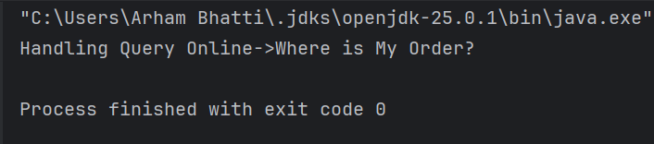
Scenario 2 – Apply Abstract Factory
Code:
interface MobileDevice{
void checkBattery();
}
interface LaptopDevice{
void runDiagnostics();
}
class Smartphones implements MobileDevice{
@Override
public void checkBattery() {
System.out.println("SmartPhones battery check...");
}
}
class Tablets implements MobileDevice{
@Override
public void checkBattery() {
System.out.println("Tablets battery check...");
}
}
class Smartwatches implements MobileDevice{
@Override
public void checkBattery() {
System.out.println("Smartwatch battery check...");
}
}
class Gaming implements LaptopDevice{
@Override
public void runDiagnostics() {
System.out.println("Running diagnostics on Gaming...");
}
}
class Business implements LaptopDevice{
@Override
public void runDiagnostics() {
System.out.println("Running diagnostics on Business...");
}
}
class Ultrabooks implements LaptopDevice{
@Override
public void runDiagnostics() {
System.out.println("Running diagnostics on Ultrabook...");
}
}
interface ElectronicFactory{
MobileDevice createMobile(String type);
LaptopDevice createLaptop(String type);
}
class MobileFactory implements ElectronicFactory{
public MobileDevice createMobile(String type) {
if (type.equalsIgnoreCase("smartphone")) {
return new Smartphones();
} else if (type.equalsIgnoreCase("tablet")) {
return new Tablets();
} else if (type.equalsIgnoreCase("smartwatch")) {
return new Smartwatches();
}
throw new IllegalArgumentException("Invalid mobile type");
}
@Override
public LaptopDevice createLaptop(String type) {
return null;
}
}
class LaptopFactory implements ElectronicFactory{
@Override
public MobileDevice createMobile(String type) {
return null;
}
public LaptopDevice createLaptop(String type) {
if (type.equalsIgnoreCase("gaming")) {
return new Gaming();
} else if (type.equalsIgnoreCase("business")) {
return new Business();
} else if (type.equalsIgnoreCase("ultrabook")) {
return new Ultrabooks();
}
throw new IllegalArgumentException("Invalid laptop type");
}
}
class FactoryProducer{
public static ElectronicFactory getFactory(String type){
if (type.equalsIgnoreCase("Mobile")){
return new MobileFactory();
}else if (type.equalsIgnoreCase("Laptop")) {
return new LaptopFactory();
}else {
throw new IllegalArgumentException("Invalid Type....");
}
}
}
public class OnlineStore {
public static void main(String[] args) {
ElectronicFactory factory=FactoryProducer.getFactory("Mobile");
MobileDevice mobileDevice= factory.createMobile("smartphone");
mobileDevice.checkBattery();
}
}

Output:
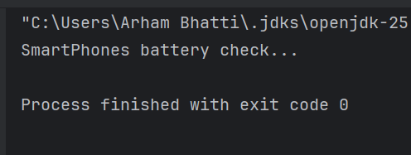

Scenario 3 – Identify & Apply
Ans: I would use Observer design pattern in this scenario.
Code:
import java.util.ArrayList;
import java.util.List;
/*Problem:
You are building a weather tracking system that notifies users whenever there is a change in
weather conditions. Various clients (e.g., mobile app, website, email) need to receive these
updates in real-time. The weather system should notify all clients whenever the weather data
changes, without knowing how each client will use the data.
Question:
Which design pattern would you use to solve this problem?
Question: Write Code in Java.*/
interface Observer{
void update(String data);
}
class MobileApp implements Observer {
public void update(String weatherData) {
System.out.println("Mobile App received update: " + weatherData);
}
}
class Website implements Observer {
public void update(String weatherData) {
System.out.println("Website received update: " + weatherData);
}
}
class EmailService implements Observer {
public void update(String weatherData) {
System.out.println("Email Service received update: " + weatherData);
}
}
interface Subject{
void addObserver(Observer o);
void removeObserver(Observer o);
void notifyObservers();
}
class WeatherStation implements Subject{
private List<Observer> observers = new ArrayList<>();
private String weatherData;
public void setWeatherData(String data) {
this.weatherData = data;
notifyObservers();
}
@Override
public void addObserver(Observer o) {
observers.add(o);
}
@Override
public void removeObserver(Observer o) {
observers.remove(o);
}
@Override
public void notifyObservers() {
for (Observer o:observers){
o.update(weatherData);
}
}
}
public class WeatherApp {
public static void main(String[] args) {
WeatherStation station = new WeatherStation();
Observer mobile = new MobileApp();
Observer web = new Website();
Observer email = new EmailService();
station.addObserver(mobile);
station.addObserver(web);
station.addObserver(email);
station.setWeatherData("Sunny, 30°C");
System.out.println("------");
station.setWeatherData("Rainy, 22°C");
}
}
Output:
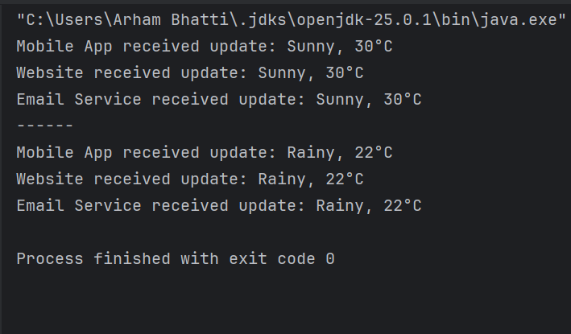
Scenario 4 – Identify & Apply
Ans: I would use Decorator design pattern in this scenario.
Design Principle: Open/Closed Principle
Code:
interface Meal {
String getDescription();
double getCost();
}
class BasicMeal implements Meal {
public String getDescription() {
return "Rice + Vegetables + Protein";
}
public double getCost() {
return 5.0;
}
}
class MealDecorator implements Meal {
protected Meal meal;
public MealDecorator(Meal meal) {
this.meal = meal;
}
public String getDescription() {
return meal.getDescription();
}
public double getCost() {
return meal.getCost();
}
}
class Nuts extends MealDecorator {
public Nuts(Meal meal) {
super(meal);
}
public String getDescription() {
return meal.getDescription() + ", Nuts";
}
public double getCost() {
return meal.getCost() + 1.5;
}
}
class Fruits extends MealDecorator {
public Fruits(Meal meal) {
super(meal);
}
public String getDescription() {
return meal.getDescription() + ", Fruits";
}
public double getCost() {
return meal.getCost() + 2.0;
}
}
class Sauce extends MealDecorator {
public Sauce(Meal meal) {
super(meal);
}
public String getDescription() {
return meal.getDescription() + ", Sauce";
}
public double getCost() {
return meal.getCost() + 1.0;
}
}
public class MealApp {
public static void main(String[] args) {
Meal meal = new BasicMeal();
meal = new Nuts(meal);
meal = new Fruits(meal);
meal = new Sauce(meal);
System.out.println("Meal: " + meal.getDescription());
System.out.println("Total Cost: $" + meal.getCost());
}
}
Output:
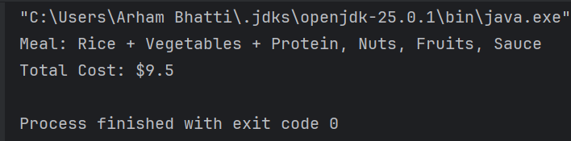

Scenario 5
Code:
A
import java.util.HashSet;
import java.util.Set;
class RideManager {
private static RideManager instance;
private Set<Integer> assignedRides = new HashSet<>();
private RideManager() {
System.out.println("RideManager created!");
}
public static RideManager getInstance() {
if (instance == null) {
instance = new RideManager();
}
return instance;
}
public void assignRide(String userName) {
int rideNumber = assignedRides.size() + 1;
assignedRides.add(rideNumber);
System.out.println(userName + " assigned ride #" + rideNumber);
}
public void showAssignedRides() {
System.out.println("Assigned rides: " + assignedRides);
}
}
public class RideSharingApp {
public static void main(String[] args) {
RideManager user1 = RideManager.getInstance();
user1.assignRide("User1");
user1.assignRide("User2");
RideManager user2 = RideManager.getInstance();
user2.assignRide("User3");
System.out.println("\n--- FIXED OUTPUT ---");
user1.showAssignedRides();
user2.showAssignedRides();
}
}
Output:
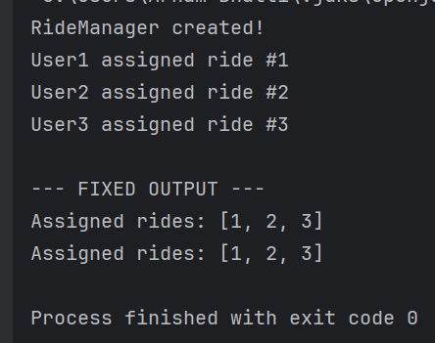
B
Code:
import java.util.ArrayList;
import java.util.List;
interface Observer {
void update(String bidder);
}
class EmailNotification implements Observer {
public void update(String bidder) {
System.out.println("Email sent to: " + bidder);
}
}
class SMSNotification implements Observer {
public void update(String bidder) {
System.out.println("SMS sent to: " + bidder);
}
}
interface Subject {
void addObserver(Observer o);
void removeObserver(Observer o);
void notifyObservers();
}
class Auction implements Subject {
private List<Observer> observers = new ArrayList<>();
private String currentBidder;
public void placeBid(String user) {
currentBidder = user;
System.out.println("Bid placed by: " + user);
notifyObservers();
}
public void addObserver(Observer o) {
observers.add(o);
}
public void removeObserver(Observer o) {
observers.remove(o);
}
public void notifyObservers() {
for (Observer o : observers) {
o.update(currentBidder);
}
}
}
public class AuctionSystem {
public static void main(String[] args) {
Auction auction = new Auction();
auction.addObserver(new EmailNotification());
auction.addObserver(new SMSNotification());
auction.placeBid("Arham");
}
}
Output:
